King’s College London/ Wipro supported: MA in STEM Education

Quarterly report: Year 4 Q1 (Report 16) (July - September 2022)

The MA in STEM Education educates future leaders working across a diverse variety of STEM-related organisations. The programme is based in the School of Education, Communication and Society and commenced in September 2019. Since the programme began, WIPRO has annually funded 15 scholarships for teachers to study for a MA and through additional funds supported the development of the programme.

This report summaries key activities undertaken between July-September 2022 to support the progress of the programme. Going forward, as agreed with WIPRO representatives a standing item will be an update on marketing and comms and impact.

Student update
Class of 2022-23/4 in numbers

Total number incoming estimate | 17
Overseas | 5
Home | 12 | Subjects – all secondary  Biology 5  Chemistry 2  Physics 1  Mathematics 1  Computing 2  Geography 0  D&T 0
Scholarships awarded to Home students | 8

We are extremely proud of the number of part-time home students we have recruited onto the programme this year, which sets us apart from our sister programmes. However, our target was to have welcomed 25 students and been able to award all of the annual scholarships (15).

Class of 21-23
There are 25 returning students. All students are to complete their dissertations, with several completing taught modules or auditing modules. Several students are returning from interruptions from their studies.

Programme curriculum
External examiner comments were received in July 2022 following the examination board. Dr Ann Childs, Oxford University, reviewed a sample of assessments from across all the STEM ed modules. Commenting on students’ performance taking the Making and Creating module (which did not run in 2021), she said:

There was some really impressive work here […]in the STEM Making and Creating module (9 distinctions out of 20 students). The strongest work is impressively theoretical but also practical! These pieces of work sustain high levels of engagement and understanding of the theoretical power of the literature to offer them fresh insights into practice and, in doing so, they hold together some complex theoretical ideas with confidence and clarity. They are really powerful and exciting to read.

We were delighted to receive 100 per cent overall student satisfaction rating (17 replies) in the Postgraduate Taught Experience Survey (PTES).This compares to the School average of 85 per cent. Finally, in July, the Programme Reps reported students across the cohorts as ‘very satisfied’ with the level of support, academic rigour, programme organisation & assessment feedback.

Dissertations submitted at the end of August are currented being assessed. Our intention is to award a prize for the ‘best’ dissertation at the November celebration. We are also encouraging past students to consider writing their research up for a different audience e.g. professional / academic journals/ blogs.

Following a review of the Research Methods and Dissertation module we have developed a bespoke MA in STEM Education research seminar series this academic year. CRESTEM colleagues, alongside external speakers, will be leading these sessions which will run both on-line and on-campus throughout the year. We anticipate that these formalised sessions will offer a method for part-time students to keep more in-touch with each other during their final year.

Further innovation projects funded by WIPRO
The STEM Education student resource page is now live and will be under review during the term to establish how students use the resources and what else is needed. The resource page host 4 case studies which will be integrated this term into the taught modules. The resource page also hosts the series of videos produced to highlight the benefits of undertaking the STEM education placement. We were pleased that past student Maia and current hosts WWF were able to get involved. We have advertised for current students and alumni to host the regional STEM hubs. We have received a number of interesting proposals which we will be reviewing and making decisions on in early October.

Marketing, Communication & Impact
Heather King, Lulu Healy, Richard Brock and Melissa Glackin met with the School marketing and communication manager, Cleo Fatoorehchi, to set out a year long plan to ensure that the scholarships are advertised early and circulated widely, including in national press and subject associations. We have appointed a current second year student, Jessica, to work as our communication ‘guru’ using WIPRO funds. Jessica is a teacher in Portsmouth and will be a great advocate for the programme having successfully completed the first year.

Richard circulated an anonymous survey to scholarship awardees completing the programme in September. Six students responded and acknowledged the value of the scholarship:

I was able to take up the opportunity to complete the STEM education Masters, which would have been difficult financially (impossible) had the scholarship not been available.

Without the scholarship I would not have been able to undertake a Master's degree due to finances, so I would like to say thank you!

Additionally, the value of WIPRO’s support was emphasised in an acknowledgement section of a dissertation:

I am thankful to Wipro Limited, without their scholarship I would not have been able to undertake this degree, which has been something I have wanted to do for several years.

On the survey, the students reported several impacts from their engagement with the course including:

I have been made the STEM director within my setting so that I can oversee and ensure that students are exposed to a rich STEM offering within my setting. Within this role I have been able to implement many initiatives that I have developed as a result of studying on the MA STEM Education course.

It did allow me to start up my own science edtech company that is currently growing.

I cannot begin to explain how big the impact has been….Within my workplace currently, I am now involved with SLT in the writing of STEM into the curriculum in our school, with the hope of influencing the whole MAT that the school is part of. I have already implemented lots of the learnings into KS3 science at the school. We are also in the process of starting a maker space which we hope will not only benefit the school, but also the community.

The students feel their work is having a wide impact:

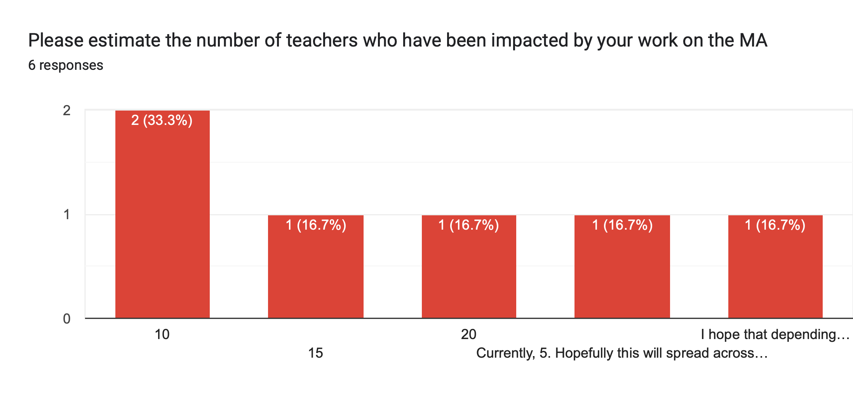
The respondents report that hundreds of students have been impacted by their learning on the MA programme.

Next quarter
Activities for next quarter will include:
- Complete dissertation assessments (October 2022)
- Commence teaching the new Research Methods Seminar programme, and welcome all students back
- Arrange the MA STEM education annual celebration – November 19th
- Further develop a marketing and communication plan for 2022-23
- Establish the three regional hubs and systems to support their working.

Professor Liviu Matei


Head of School, School of Education, Communication & Society

